**Methods in Ecology and Evolution Supporting Information**

Article title: --add--

Authors: Sal Curasi, Ian Klupar, Adrian Rocha

(leave 1st page blank for required information and maybe a table of contents)

**Methods S0:** Introduction

The following instructions will walk through the assembly process of a multi-channel, independently powered temperature data logger. The sensors on the temperature logger are intended for use in soil but can be used to measure air temperature or any other temperature environment between the ranges of -20C and +85C. Temperature data is logged in a spread sheet in the form of a ‘.csv’ file that is stored on a removable SD card. Therefore, temperature data can be removed from the logger system without disrupting the placement of the temperature sensors, a particularly useful feature in permafrost environments. The temperature logger hardware is equipped for use with 10 external temperature sensors but can also use as few as 1. The logger will record data at set intervals. The default logging interval is 20 minutes, but this interval can be adjusted. The current battery life of a single data logger is approximately 2 years using 20-minute logging intervals. However, adjusting the time interval will greatly affect the batter life of the logger. Following these written instructions and watching the accompanying instructional videos will result in a functional temperature logger. We also offer instructions for an external case for the logger for outdoor use, but this design is largely up to the user and varies between different applications. In our experience, most loggers have failed due to water damage from a leaky enclosure.

All of the files that are required for assembly can be found in the folder titled “*temp_logger_files”*. Specifically, this folder contains a complete list of electrical components and tools required for assembly as well as the programming.

**Methods S1:** Getting Started

*1.1 Getting the tools and programming devices*

In order to construct the temperature logger, you will need electronics assembly tools (see table S1 or the tools tab in parts_list.xlsx for more information and URLs). We estimate that the tools needed to construct the temperature logger can be purchased new for under $90. However, many of them are commonly found around the lab or home.

|  |  |  |  |
| --- | --- | --- | --- |
| **Tool Type** | **Approx. cost (USD $)** | **ID** | **Description** |
| Mechanical | 75.00 |  | Soldering Iron |
| Mechanical | 15.00 |  | 60/40 Tin-Lead Solder with 1.8% Flux and 0.6mm diameter |
| Mechanical | 11.95 | (a) | Precision Flat Pliers |
| Mechanical | 7.25 | (b) | Flush Diagonal Cutters |
| Mechanical | 34.95 | (c) | Ratcheted Crimper Pliers |
| Mechanical |  | (d) | Wire Strippers |
| Programmer | 27.5 | (e) | PICKit3 Micropchip Programmer with ICSP Socket |
| Programmer | 17.00 | (f) | AVR ISP Programmer Shield (Burn Bootloader Programmer) |
| Programmer | 23.00 | (g) | Arduino Uno |
| Programmer | 14.75 | (h) | FTDI Friend |
| Programmer | 6.00 |  | Bread Board (Optional) |
| **Total** | 232.40 |  |  |

**Table S1:** Required mechanical and programming tools with approximate prices.

 

**Table S1a:** Images of the programmer and Mechanical Tools required

Specifically, we recommend purchasing the ratcheted crimper pliers linked to in *all_tools_and_parts.xlsx* from Adafruit (<https://www.adafruit.com/product/1213>) as it makes assembling reliable temperature loggers easier. There are a variety of crimper pliers on the web, but these specific ones have the correct dimensions for the use in this tutorial. The crimper is used to fasten a metal crimp contact onto the wires at the end of the temperature sensor. The dimensions of the metal crimp contact match the dimension of the crimper pliers we recommend which allows the user to easily attach the crimp contact to the temperature probe.

We also recommend purchasing the programmer tools linked to in *all_tools_and_parts.xlsx* unless you are an advanced user with an in depth understanding of the Arduino or PIC microcontroller platforms. Some of the parts may have been retired by the manufacturer, but research on the web should result in affordable alternatives.

*1.2 Ordering printed circuit boards*

In order to simplify the temperature logger assembly process and increase reliability, we designed a printed circuit board (PCB). The files needed to have this board produced are located in the *Seeed_PCB* folder inside the ‘parts’ folder. Editable CAD files are also available in this folder.

We recommend purchasing printed circuit boards through Seeed studio’s fusion PCB service (see: <https://www.seeedstudio.com/>fusion_pcb.html). To accomplish this task, you will need to upload the Gerber files provided in zip format in the *parts* folder labeled *Seeed_PCB.zip* (see figure S1) and enter the applicable production parameters (see table S2)

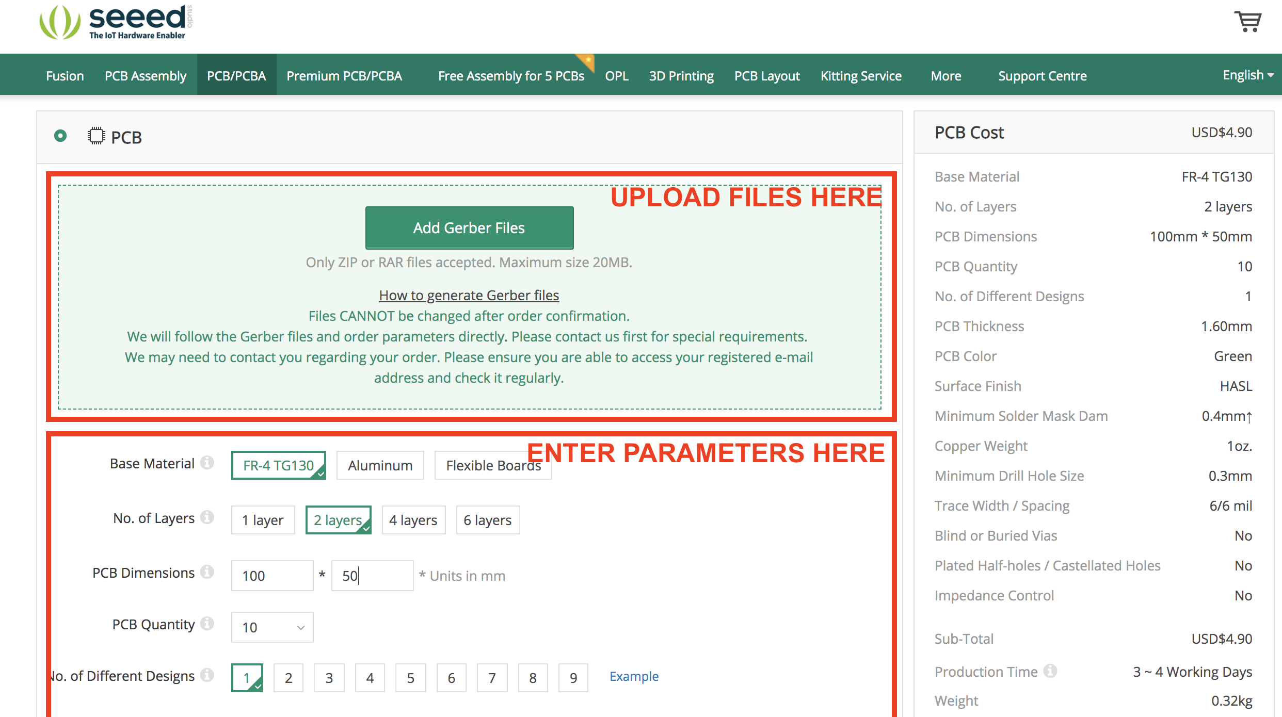

**Figure S1:** Screen shot of the Seeedstudio fusion PCB interface with annotations showing where to upload Gerber files and input board production parameters.

|  |  |
| --- | --- |
| **Parameter** | **Selected Value** |
| Base material | FR-4 TG130 |
| Number of layers | 2 |
| PCB Dimensions | 100mm by 50mm |
| PCB quantity | User determined |
| Number of difference designs | 1 |
| PCB thickness | 1.60 |
| PCB color | Green |
| Surface finish | HASL |
| Maximum solder mask dam | 0.4mm |
| Copper weight | 1 oz |
| Minimum drill hole size | 0.3mm |
| Trace width/spacing | 6/6 mil |
| Blind or buried vias | No |
| Plated half-holes/castellated holes | No |
| Impedance control | No |
| PCB assembly | Leave unselected |
| SMT stencil | Leave unselected |

**Table S2:** Table listing all applicable circuit board productions parameters.

*1.3 Ordering temperature logger components*

You will need to purchase electronic components in order to construct the temperature logger (see table S3 or the Components tab in *all_tools_and_parts_list.xlsx* for more information). We estimate that approximately $46 dollars in components is needed to build a 3-channel temperature data logger. However, purchasing components in large quantities and shopping around (especially in the case of the 1-meter DS18B20 Temperature Probes and the 8 - 16GB SD cards) could substantially reduce the price. We suggest ordering parts from the fewest manufactures possible to simplify the ordering process, but there is nothing inherently different between the components we suggest and alternatives as long as they meet the industry standards.

The temperature loggers require 30 unique components and as a result, online ordering and shipment of the components can be difficult. To simplify the process, we recommend ordering as many components as possible from Digi-Key’s website and have included a spreadsheet titled *Digi-Key_Parts_List.csv* in the ‘parts’ folder which can be automatically uploaded to your online shopping cart on Digi-key’s website. The last 4 components on Table S3 are not offered on Digi-Key’s website and must be ordered separately. We do not recommend substituting components unless you are an advanced user.

The 1-meter DS18B20 temperature sensors can be purchased from a variety of retailers. However, they often have the longest shipment times of any component, so we recommend ordering these first. The DS18B20 temperature sensor should be consistent across retailers.

|  |  |  |  |  |
| --- | --- | --- | --- | --- |
| **Quantity** | **Digi-Key Part Number** | **Label** | **Description** | **Approx. Price ($)** |
| 1 | 296-4531-5-ND | IC4 | IC BUS BUFFER TRI-ST QD 14DIP | 0.4 |
| 1 | ED3050-5-ND | IC1 | CONN IC DIP SOCKET 28POS TIN | 0.33 |
| 1 | ED3044-5-ND | IC2, IC3 | CONN IC DIP SOCKET 8POS TIN | 0.16 |
| 3 | 952-1843-ND |  | 10POS SIL VERTICAL PIN HEADER | 0.37 |
| 1 | MCP1700-3302E/TO-ND | IC5 | IC REG LDO 3.3V 0.25A TO92-3 | 0.38 |
| 1 | PIC12F683-I/P-ND |  | IC MCU 8BIT 3.5KB FLASH 8DIP | 1.22 |
| 1 | ATMEGA328P-PU-ND |  | IC MCU 8BIT 32KB FLASH 28DIP | 2.14 |
| 2 | 754-1275-ND | L1, L3 | LED RED DIFF 5MM ROUND T/H | 0.55 |
| 1 | 754-1735-ND | L2 | LED GRN DIFF 5MM ROUND T/H | 0.48 |
| 3 | 220QBK-ND | 220 | RES 220 OHM 1/4W 5% AXIAL | 0.1 |
| 5 | 399-4264-ND | .1uf | CAP CER 0.1UF 50V X7R RADIAL | 0.22 |
| 1 | 2.0KQBK-ND | 2k | RES 2K OHM 1/4W 5% AXIAL | 0.1 |
| 6 | 10KQBK-ND | 10k | RES 10K OHM 1/4W 5% AXIAL | 0.1 |
| 1 | BC22AAW-ND |  | HOLDER BATT 2-AA CELLS WIRE LDS | 1.28 |
| 2 | 399-13930-1-ND | 22pf | CAP CER 22PF 200V C0G/NP0 RADIAL | 0.3 |
| 4 | 952-2228-ND |  | SIL FEMALE CRIMP HOUSING 3POS | 0.17 |
| 12 | 952-2157-1-ND |  | FEMALE CRIMP CONTACT SELECTIVE | 0.1 |
| 1 | 401-1812-ND | B1 (lower) | SWITCH TACTILE SPST-NO 0.01A 32V | 0.75 |
| 1 | DS1307N+-ND |  | IC RTC CLK/CALENDAR I2C 8-DIP | 4.19 |
| 1 | 535-9034-ND | Y2 | CRYSTAL 32.7680KHZ 12.5PF T/H | 0.17 |
| 1 | SY033-ND |  | BATTERY LITHIUM 3V COIN 12.5MM | 0.7 |
| 1 | 952-2247-ND |  | SIL HORIZ PC TAIL PIN HEADER | 0.35 |
| 1 | BC501SM-ND | B1 (upper) | HOLDER COIN CELL FOR CR1220 SMD | 1.14 |
| 1 | DS18B20+-ND | DS18B20 | SENSOR TEMPERATURE 1-WIRE TO92-3 | 3.06 |
| 1 | 4.7KQBK-ND | 4.7k | RES 4.7K OHM 1/4W 5% AXIAL | 0.1 |
| 1 | CTX415-ND | Y1 | CRYSTAL 16.0000MHZ 20PF T/H | 0.38 |
| 1 | NA |  | Pololu 5V Step-Up Voltage Regulator U1V11F5 | 4.95 |
| 1 | NA | SD1 | Memory Socket, Memory Card, 9 Contacts, Phosphor Bronze, Gold Plated Contacts | 2.44 |
| 1 | NA |  | 8 - 16GB SD card | 3.75 |
| 4 | NA |  | 1-meter DS18B20 Temperature Sensor with Stainless Steel Package | 1.8 |
|  |  |  | **Total** | 33.67 |

**Table S3:** Required components

Once you have ordered and received all the components necessary to assemble a completed board, you are ready to begin the assembly process. Before starting, we recommend reading through the whole assembly process. Table S3, along with having detailed descriptions, required numbers and cost, also has the placement of the component on the PCB as indicated labels next to the outlines on the PCB. Use this table to help identify the placement of the components within the correct outline on the board in the next sections.

**Methods S2:** Step-by-step assembly instructions

*2.1 Attaching crimp contacts to the temperature sensors*

The temperature sensors are attached to the data logger circuit board using crimp contact servo plugs. These crimp contacts need to be attached to the three wires of each sensor. To do this, strip roughly 2 mm of housing off the ends of the three wires as in S3a. The colors of the wires will often vary depending on where the sensors are purchased (check with the manufacturer for more information). However, there will always be a ground, +5V and signal wire. The ground and +5V wire will often be black and red respectively (figure S3a).

Once all three wires have been striped, place the wire into the crimp contact as shown (figure S3b). The rectangle portion should overlap with the exposed wire and the triangle portion should overlap with the remaining wire housing. It is important that the triangular tabs on the end of the crimp contact are in line with the insulated part of the wire whereas the shorter rectangular tabs touch the bare metal. Then insert the wire and plug into the ratcheted crimper pliers and close the jaws of the crimper to bend the crimp contact onto the wire, effectively attaching an electrical extension onto the end of the wire (figure S3c). It can often be helpful to lightly compress the outer most tabs around the insulated part of the wire using the precision flat pliers to hold the crimp in place as you insert it into the ratcheted crimper. Finally, insert the individual crimp contacts into the black plastic crimp housing. You will hear a click when the plug is seated in place and the tabs on the front of the crimp housing will lay flush with the rest of the housing. If you don’t hear a click or the housing slips off, you may be inserting the wires backwards or that the crimp contact is not fully inserted into the housing. The precision flat pliers are of the appropriate size to push the crimp contact fully into the housing. It is important that you assemble the plugs with the wires in the right order (+5V, ground and signal from left to right on the circuit board; figure S3d) for later steps when we eventually attach the probes to the board via vertical pins as seen in S3d. It is also important to do every probe the same way to ensure proper fit.

If you accidently bend/warp the crimp contact while using the ratcheted crimper, you will have to use the flush diagonal cutters to cut off the bent crimp contact and start the process over again. Furthermore, you may have to cut all three of the wires to the same length so that the individual wires fit into the crimp housing equally and there is not extra tension on one wire.

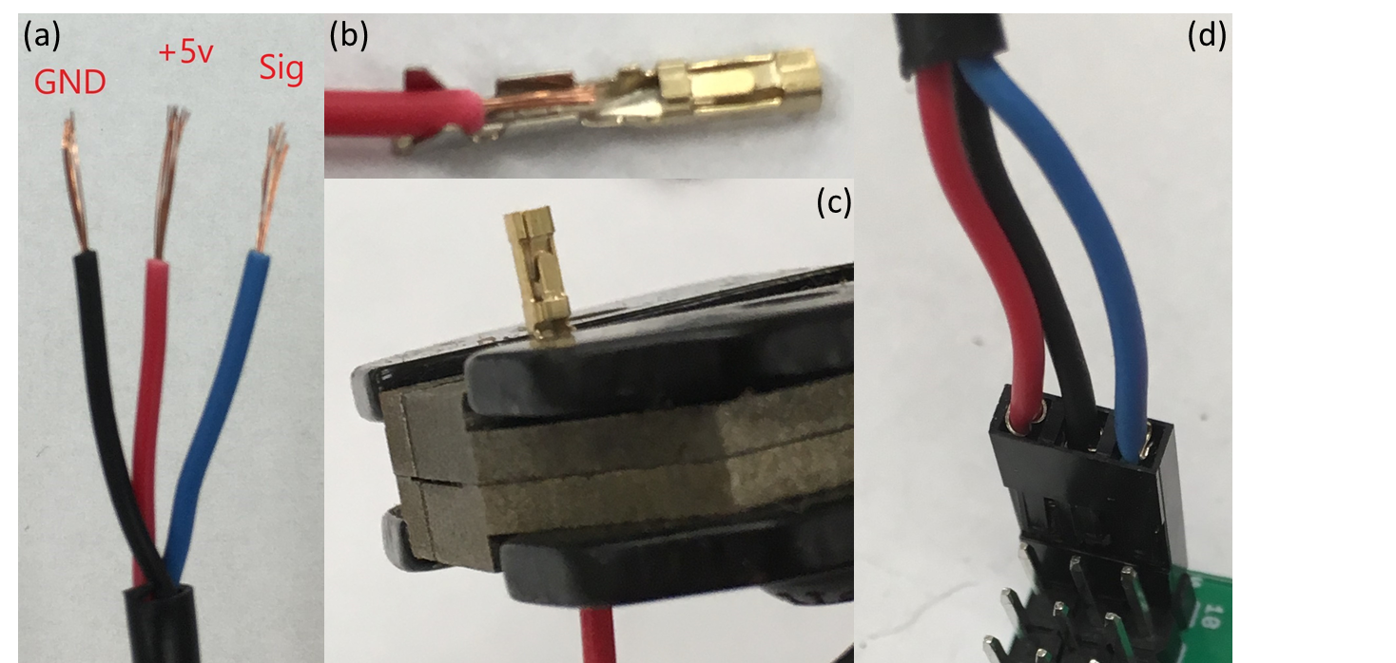

**Figure S3: (a)** The temperature sensors three wires with annotations showing their function. **(b)** Stripped temperature sensor wire in its correct position in the crimp contact **(c)** Crimp contact being attached using the ratcheted crimper **(d)** Fully assembled plug inserted into the temperature logger (note the order of the wires in the plug body)

*2.2 A note about soldering*

In our experience, incomplete or weak solder joints are the primary reason that assembled loggers fail to work when they are first powered on. Constructing the temperature logger requires over 100 solder joints to be made, 17 of which are surface mount solder joints. The majority of the soldering will be done on the reverse side of the board, but some will be done on the front side (surface mount). We recommend that you practice making strong solder joints before attempting to assemble your first temperature logger if you are new to soldering. Basic, learn-to-solder tutorials (e.g. https://youtu.be/v4D_Rdp1uh8) are freely available on the internet and you can get hands-on practice by soldering extra or inexpensive components (such as resistors and capacitors) to spare circuit boards. These videos cover the difference between a good solder joint and a bad solder joint which is critical knowledge when assembling these temperature loggers. It is also important to have a sense of how solder flows onto a joint and how much solder is too much solder. Luckily, a bad solder connection can usually be fixed by heating up the joint and adding a small amount of solder, so don’t discard any progress after a bad solder joint, it happens to the best of us.

After you have soldered a component to the circuit board, and you feel confident about the join, you can use the flush diagonal cutters to clip off the extra ends of the components on the back side of the board where applicable. This allows you more room to work when soldering on additional components in later steps.

*2.3 Preparing the voltage regulator*

The Pololu 5V Step-Up voltage regulator must be assembled and modified in preparation for use in the temperature logger. First, solder the right-angle header that comes in the packaging to the back of the circuit board as pictured in figure S2a.

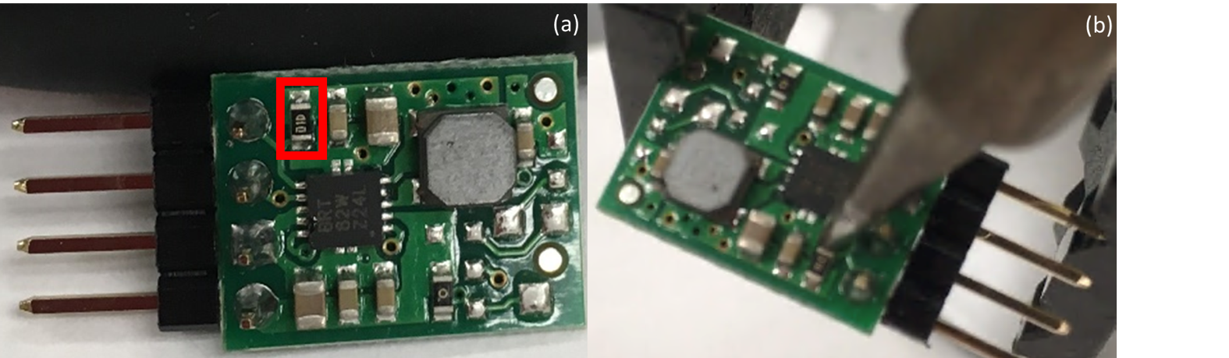

**Figure S2: a)** Voltage regulator with right angle header installed from the backside. Annotated to show the location of the 100 ohm resistor **b)** Soldering iron positioned to remove the 100 ohm resistor.

Next, you must remove a surface mount 100 ohm resistor from the circuit board. To do this, locate the resistor on the board (see figure S2a). Place the tip of your soldering iron on one end of the resistor as pictured in figure S2b and heat it up for a few seconds or until the solder holding the resistor has melted. When the solder on both sides of the resistor has melted, you’ll be able to flick it off the board using the iron tip (note: It can be helpful to hold the regulator using a plier or vice. Adding a tiny bit of solder to the tip of your iron to aid in heat transfer can also make this step much easier).

*2.4 Assembling the temperature logger*

**

**Figure S4:** Temperature logger circuit board and associated components with annotations to show the components names.

Begin by placing the SD card slot and coin cell battery holder on the circuit board as shown in figure S5. The pins on the bottom of these components should fit into the holes in the PCB properly orienting the components. Then solder the components in place. It’s important to start with these two components as the surface mount connections can be hard to make once the PCB gets cluttered with other components. If solder ends up bridging any of the connections on the SD, be sure to remove it using the soldering iron. The pads for the SD card slot are close together and can lead to solder making unwanted connections. Soldering on the SD card slot will likely be the most difficult component to solder onto the board.

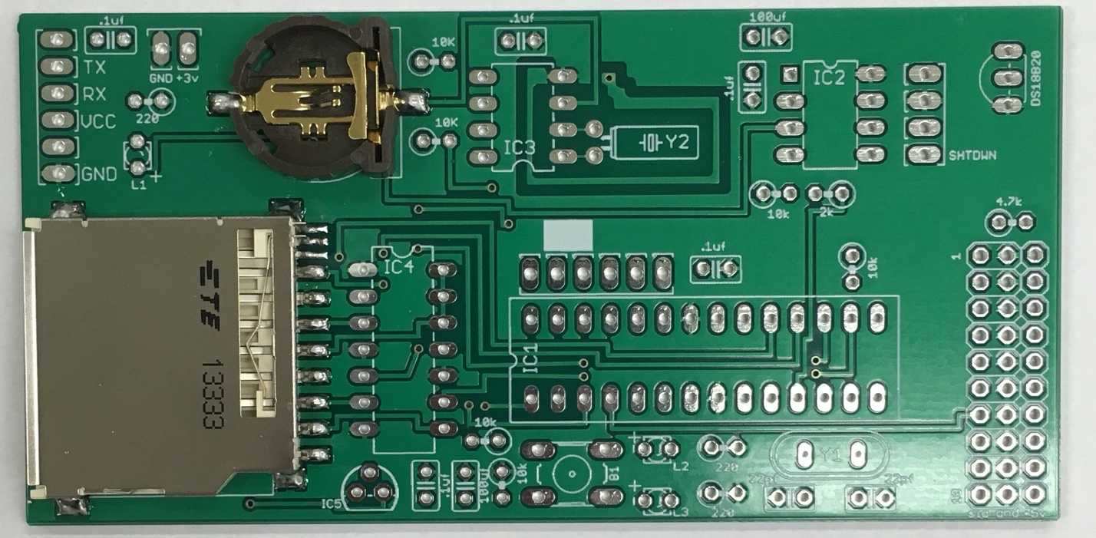

**Figure S5:** Printed circuit board with the SD card slot and coin cell battery holder installed

Next solder the 28-pin, 14-pin and two 4-pin integrated circuit (IC) sockets into the outlines labeled IC1, IC2, IC3, and IC4 (figure S6). Be sure to align the notch on the socket with the notch printed on the outline of the circuit board. The directionality of this component on the board is important. Alternatively, the 14-Pin IC Bus can be soldered directly into the IC4 outline, bypassing the need for a 14-pin socket. However, this is not the case for the two 8-pin sockets and the 28-pin sockets.

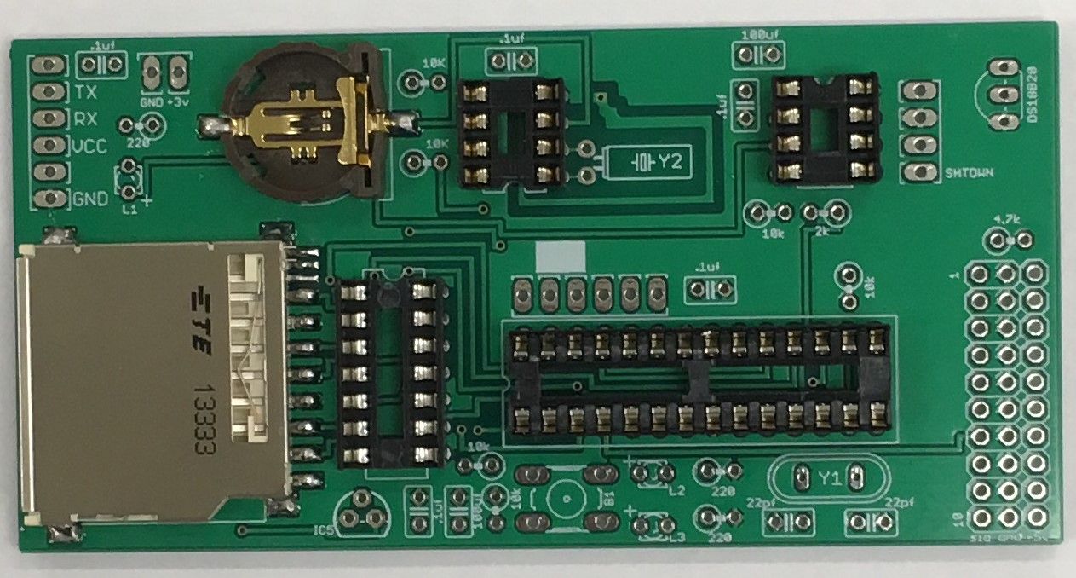

**Figure S6:** Printed circuit board with the integrated circuit sockets installed

Then, solder the three 10 pin headers and the right angle 6 pin header onto the board (figure S7). It can be helpful to use two of the temperature sensors which you built in earlier (Step 2.3) to help align the 10 pin headers as you insert them into the circuit board. The temperature probes will eventually be plugged into these pins when the board is fully assembled so it is critical that they fit before they are aligned.

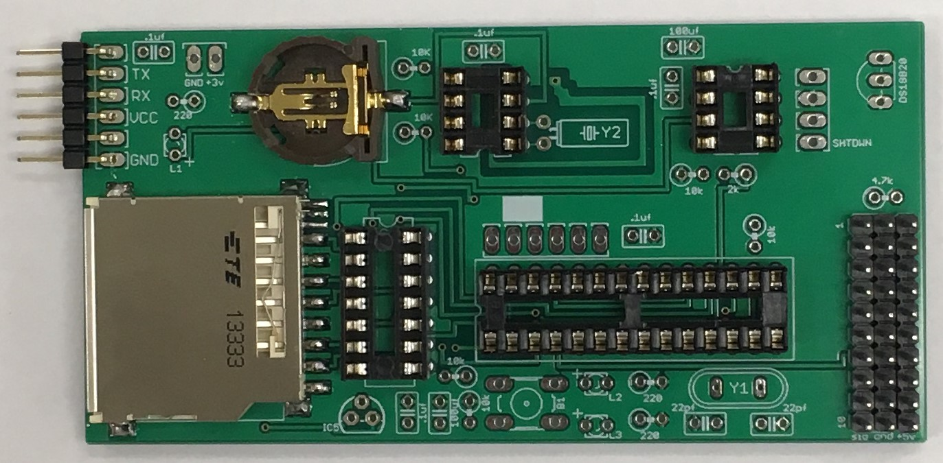

**Figure S7:** Printed circuit board with the three10-pin headers and right angle 6-pin header installed.

Next, solder the two crystal oscillators onto the circuit board (figure S8). The two crystal oscillators operate at different frequencies and are not interchangeable. Luckily, they look very different and have to separate looking outlines. It’s important the footprint on the board matches the oscillator you are soldering in place. The 32.7 kHz crystal is installed into Y2 on the board and the 16 mHz crystal is installed into Y1.

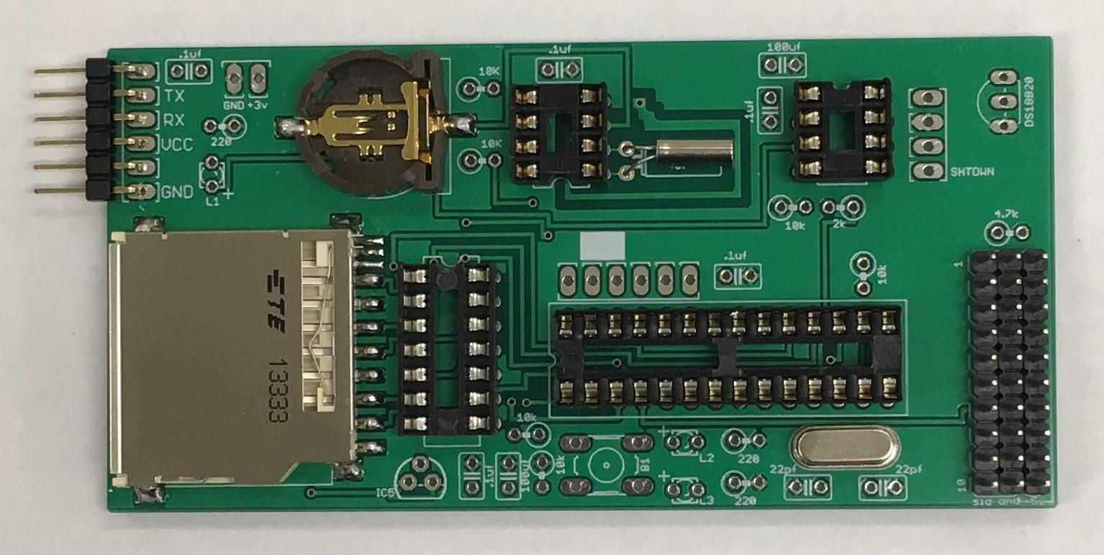

**Figure S8:** Printed circuit board with the crystal oscillators installed

Solder the DS18B20 and 3.3V voltage regulator onto the circuit board (figure S9). The component should be oriented to match the direction of the footprint printed on the circuit board. These two components look very similar but are not interchangeable so it’s important to check the model information printed on each one before installation. On the flat side of each component there are small engravings that can be used to tell them apart if they are mixed up after removing them from the packaging. The easiest way to keep them apart is to store them in their original bags which has detailed descriptions, but if they should be mixed up, the DS18B20 internal temperature sensor has the word ‘DALLAS’ engraved on the backside of the component housing, and the 3.3V regulator has ‘1700’ inscribed on its backside. Solder the 3.3V regulator into IC5 and the internal temperature sensor into the outline labeled ‘DS18B20’.

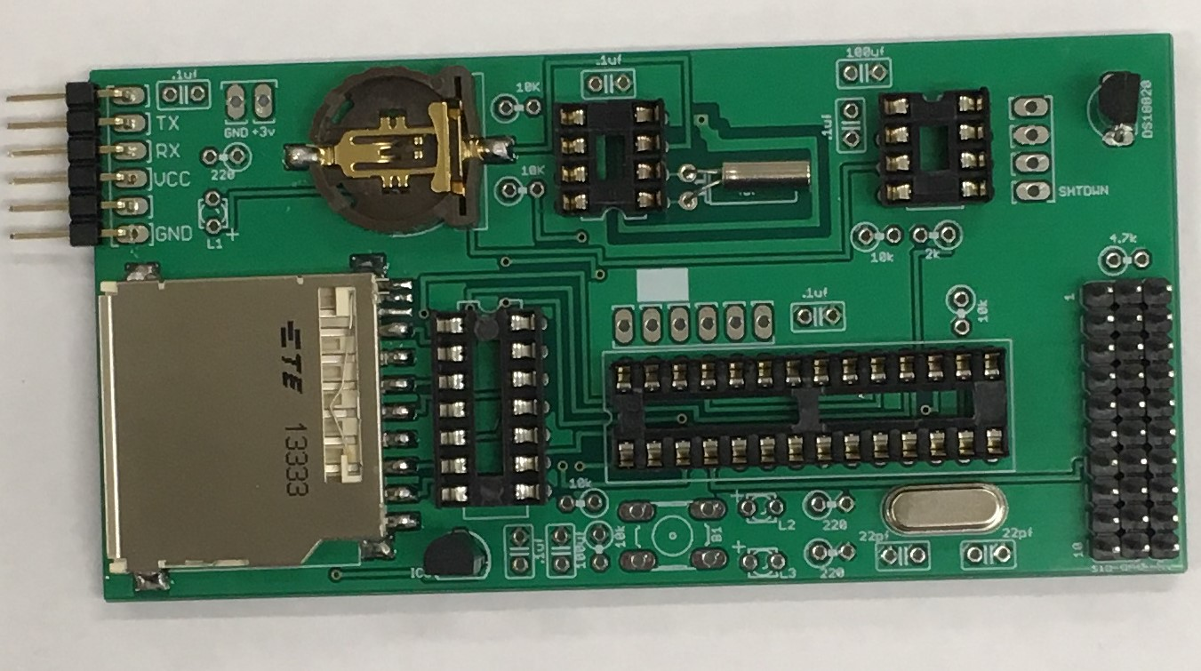

**Figure S9:** Printed circuit board with DS18B20 and 3.3v regulator installed.

Now, install the button onto the circuit board in position B1. It’s important that the button be oriented horizontal as shown in figure S10. The button may require the flat precision plier to bend the leads slightly so that they fit into the PCB correctly.

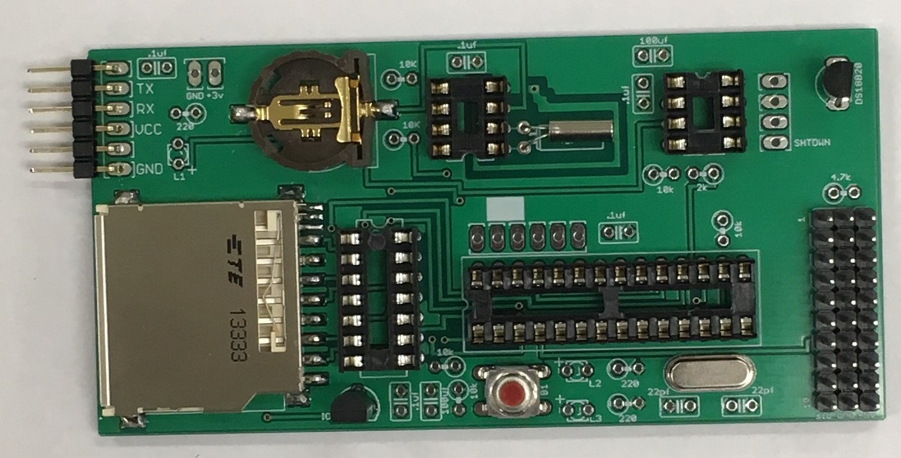

**Figure S10:** Printed circuit board with the button installed

Next, install the 3 LED’s (figure S11a,b). The orientation of the LEDs matters. LEDs have polarity, meaning that one leg is associated with positive terminal and the other is negative. There are two ways to determine which leg of the LED is positive and which is negative. In S11a, one of the legs is longer than the other, this leg is the positive terminal. Additionally, at the base of the LED, the rim around it is flat one side, the leg on that side is the negative terminal. For these LEDs, the longer (positive) leg of the LED must be installed into the hole on the circuit board labeled with a small plus (+). If the LEDs are installed backwards, they will not light up and will cause confusion during the programming stage of development. Install the 2 red LEDs into L1 and L2 and install the green LED into L3. After a successful join, use the flush diagonal cutters to remove the excess leads on the back of the board.

Then install the pololu 5V voltage regulator circuit board that you adjusted in step 2.2. It is important that the hole labeled as “SHTDWN” on the circuit board matches up with the pin labeled as “SHTDN” on the voltage regulator (figure S11c).

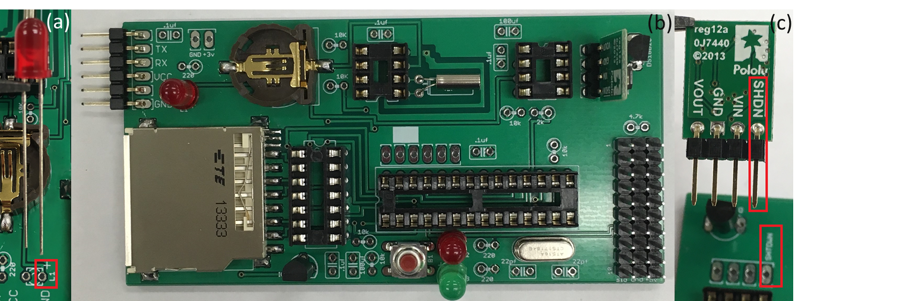

**Figure S11: (a)** The longer leg of the LEDs must be installed into the hole marked with a small plus as shown. **(b)** Printed circuit board with the three LEDs and the pololu 5v regulator installed. **(c)** The voltage regulator must be oriented as show so the “SHDN” pin is installed into the hole labeled “SHTDWN”

|  |
| --- |
|  |
| Images of the capacitors color band with identification |

Next, solder the various capacitors (figure S12a) and resistors (figure S12b) onto the circuit board. The resistors and capacitor come in a number of different values such as 10K ohm, 4.7K ohm, 2K ohm, and 220 ohm in the case of resistors and 0.1uf and 22pf in the case of capacitors. The resistors can be identified by the stripped color code printed on their packaging and the capacitors typically have markings indicating their value. We suggest keeping the resistors and capacitors separate in the labeled bags they were shipped in for easy identification. If they happen to be separated from their original packaging, there are plenty on online resources that can help identify the resistors based on their color coding. For proper installation, you will need to bend the resistors so they fit in the appropriate footprints on the circuit board. The resistance and capacitance values of the components you need to install should be clearly printed

on the circuit board. We recommend installing all of one component/value at once. After a successful join, use the flush diagonal cutters to remove the excess leads on the back of the board.

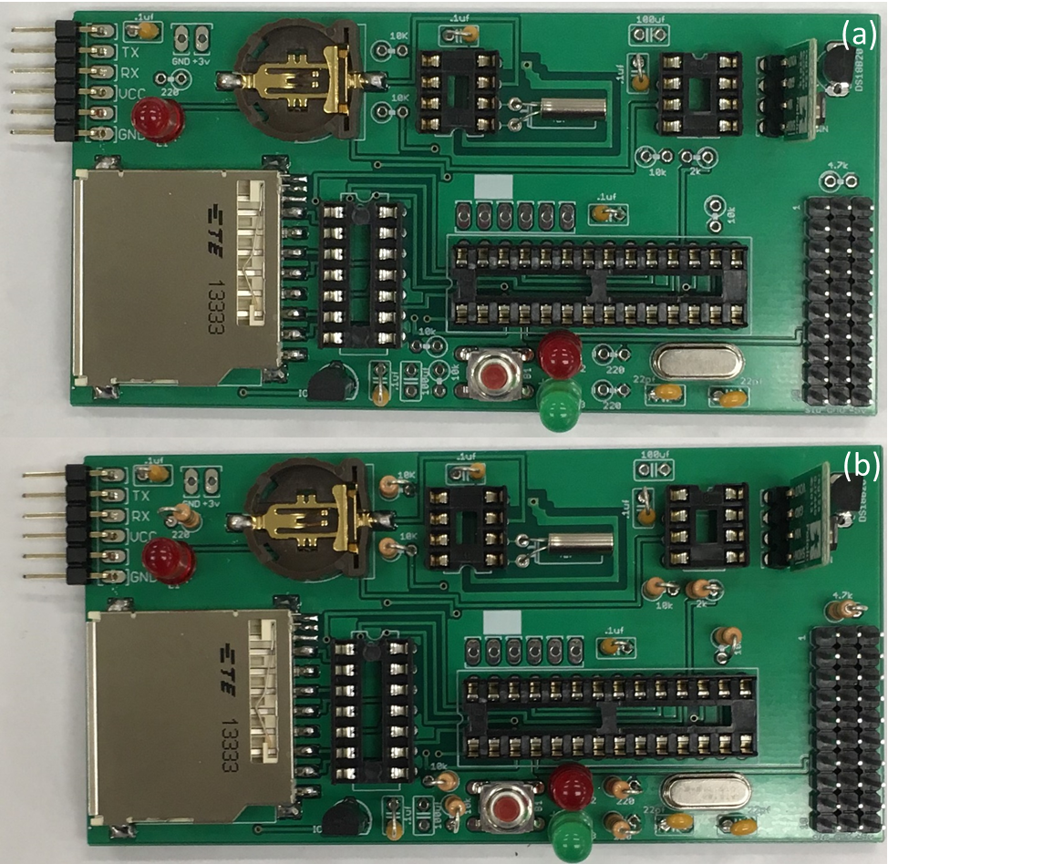

**Figure S12: (a)** Printed circuit board after all the capacitors are installed **(b)** Printed circuit board after all the resistors are installed (note the small markings on the circuit board indicating their values).

Lastly, solder the AA battery holder in place. The red wire should be connected to the +3V pad and the black wire should be connected to ground (GND). It’s a good idea to put a dab of hot glue over the battery wires to relieve tension and prevent damage (figure S13).

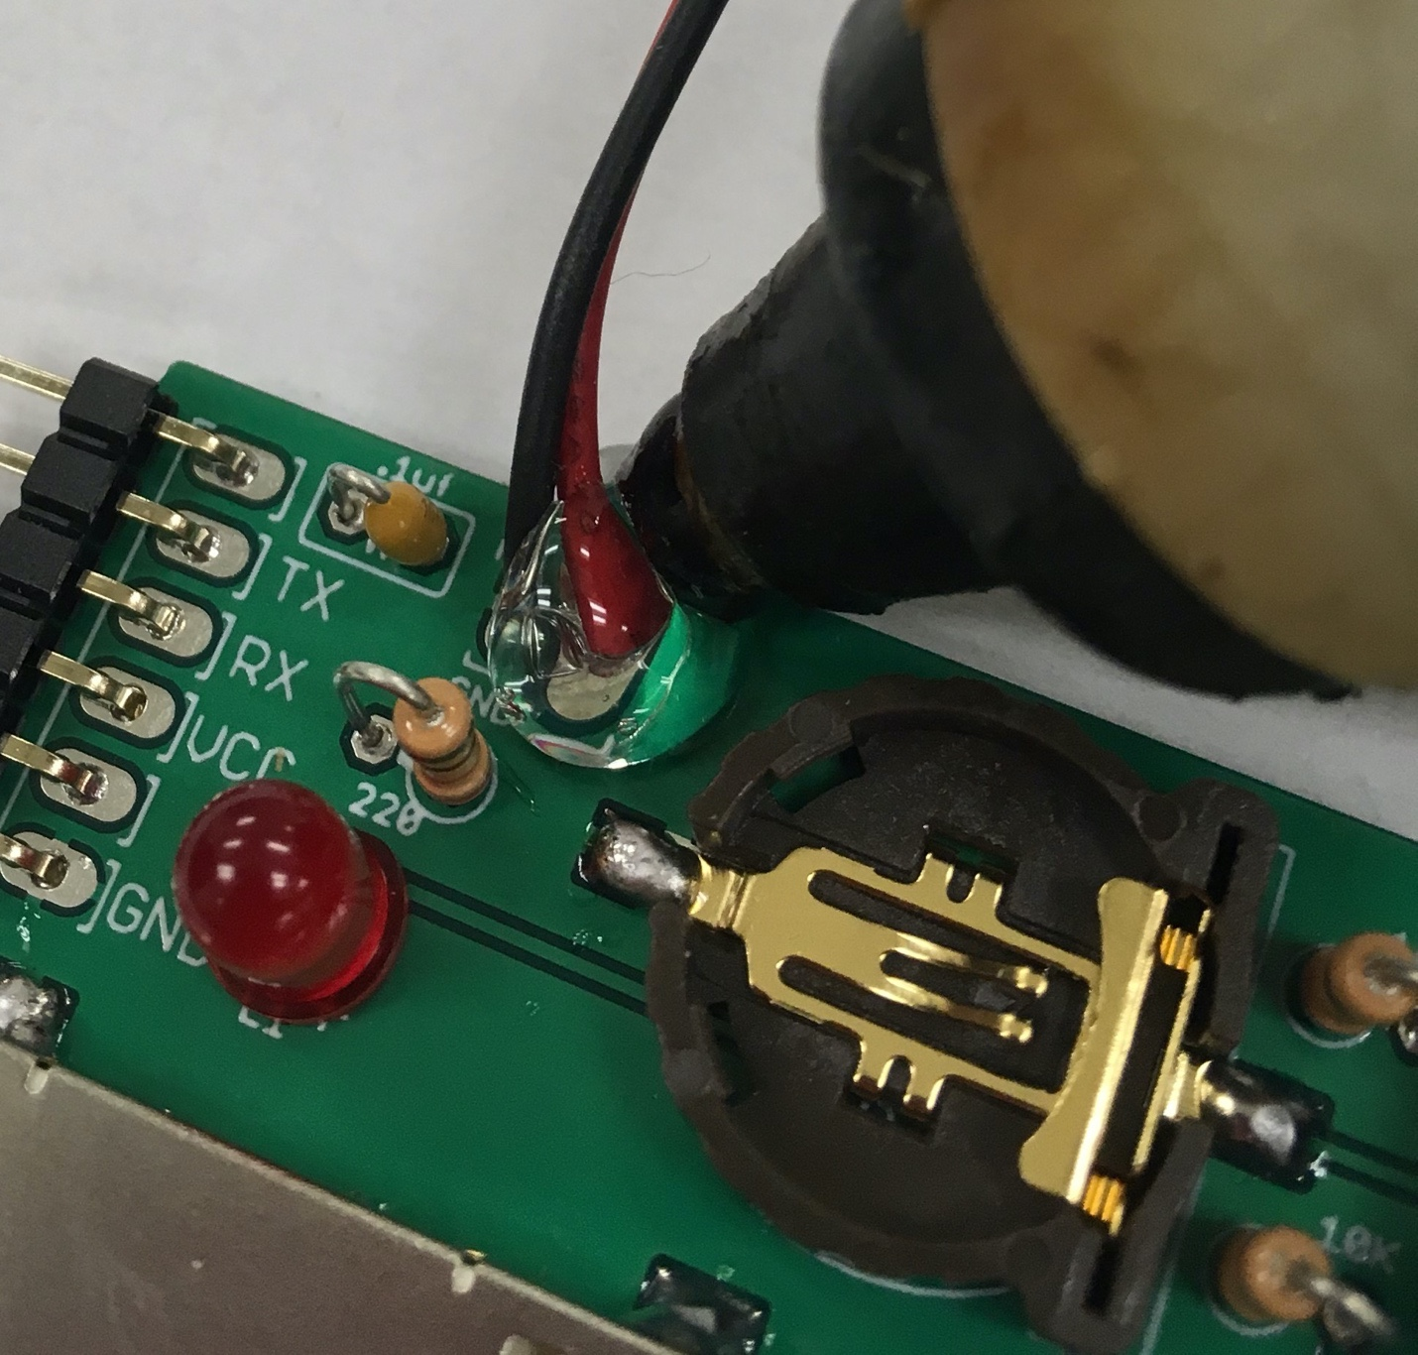

**Figure S13:** Battery holder wires installed on the circuit board with a dab of hot glue being applied to prevent accidental damage.

**Methods S3:** Programming the temperature logger

Programing the temperature logger requires a number of specific steps that are detailed below. When building temperature loggers in large numbers we recommend doing steps 3.1 and 3.2 for every chip you will be installing prior to moving on to the remaining steps. These steps exclusively require the programmer tools outlined in table S1. The following 3 steps involve programming 2 of the microchips and a final step involving the whole board.

*3.1 Burning the Arduino bootloader*

This step requires the AVR ISP programing shield, an Arduino Uno and the Arduino integrated development environment (IDE) (available here: https://www.arduino.cc/en/Main/Software). A tutorial is also available at (https://www.arduino.cc/en/Tutorial/ArduinoISP). Please note that although we list the AVR ISP programming shield as a required tool it is possible to accomplish this step using a bread board instead (see: <https://www.arduino.cc/en/Tutorial/ArduinoToBreadboard>). Boot loading the ATMEGA328P chip allows for the chip to operate as an Arduino and perform the functions of logging the temperature readings.

To begin boot loading the Arduino, assemble the AVR ISP programming shield and attached it to the Arduino Uno as pictured in figure S14a and plug the Arduino into your computers USB port, taking note of port location (Note: If you decide to use a bread board as mentioned earlier, this is where you do that). If the Arduino Uno is correctly inserted into your computer and receiving power, then the lights on the board with turn on. Next, insert an ATMEGA328P chip into the zero-insertion force socket (ZIF socket) on the AVR ISP programming shield and push the lever into the locked position (figure S14a), making direct contact between the metal pads inside the ZIF socket and the pins of the ATMEGA328P. The notch on the end of the ATMEGA238P should be facing the lever of the zero-insertion force socket and the first two pins of the chip should be in the first two available slots as shown in figure S14a. When inserted correctly, the chip should not wiggle or fall out when the AVR ISP shield is turned upside down.

Next, open an Arduino ISP sketch window by selecting the file drop-down menu and going to *File/Examples/ArduinoISP/ArduinoISP* and upload it to the Arduino Uno (figure S14b-c) by clicking on the upload arrow. Then, in the Tools drop-down menu of the Arduino IDE go to *Tools/Programmer* and select the option *Arduino as ISP* (figure S14d). Finally burn the bootloader by going to the tools drop-down menu and selecting *tools/burn* *bootloader* (figure S14e). To burn additional chips, insert the next chip into the zero-insertion force socket and select *tools/burn bootloader* from the drop-down menu.

For this step, and for the remaining programming steps in this tutorial, it is important to pay special mind to the settings of the Arduino IDE. For this step, it is important to make sure that the options for ‘*Port:’* and for ‘*Board:’* in the Tools drop-down menu are correct. The ‘*Board:’* option should always be selected as “Arduino/Genuino Uno” and the *‘Port:’* option should be set to the USB port you plugged the Arduino Uno into.

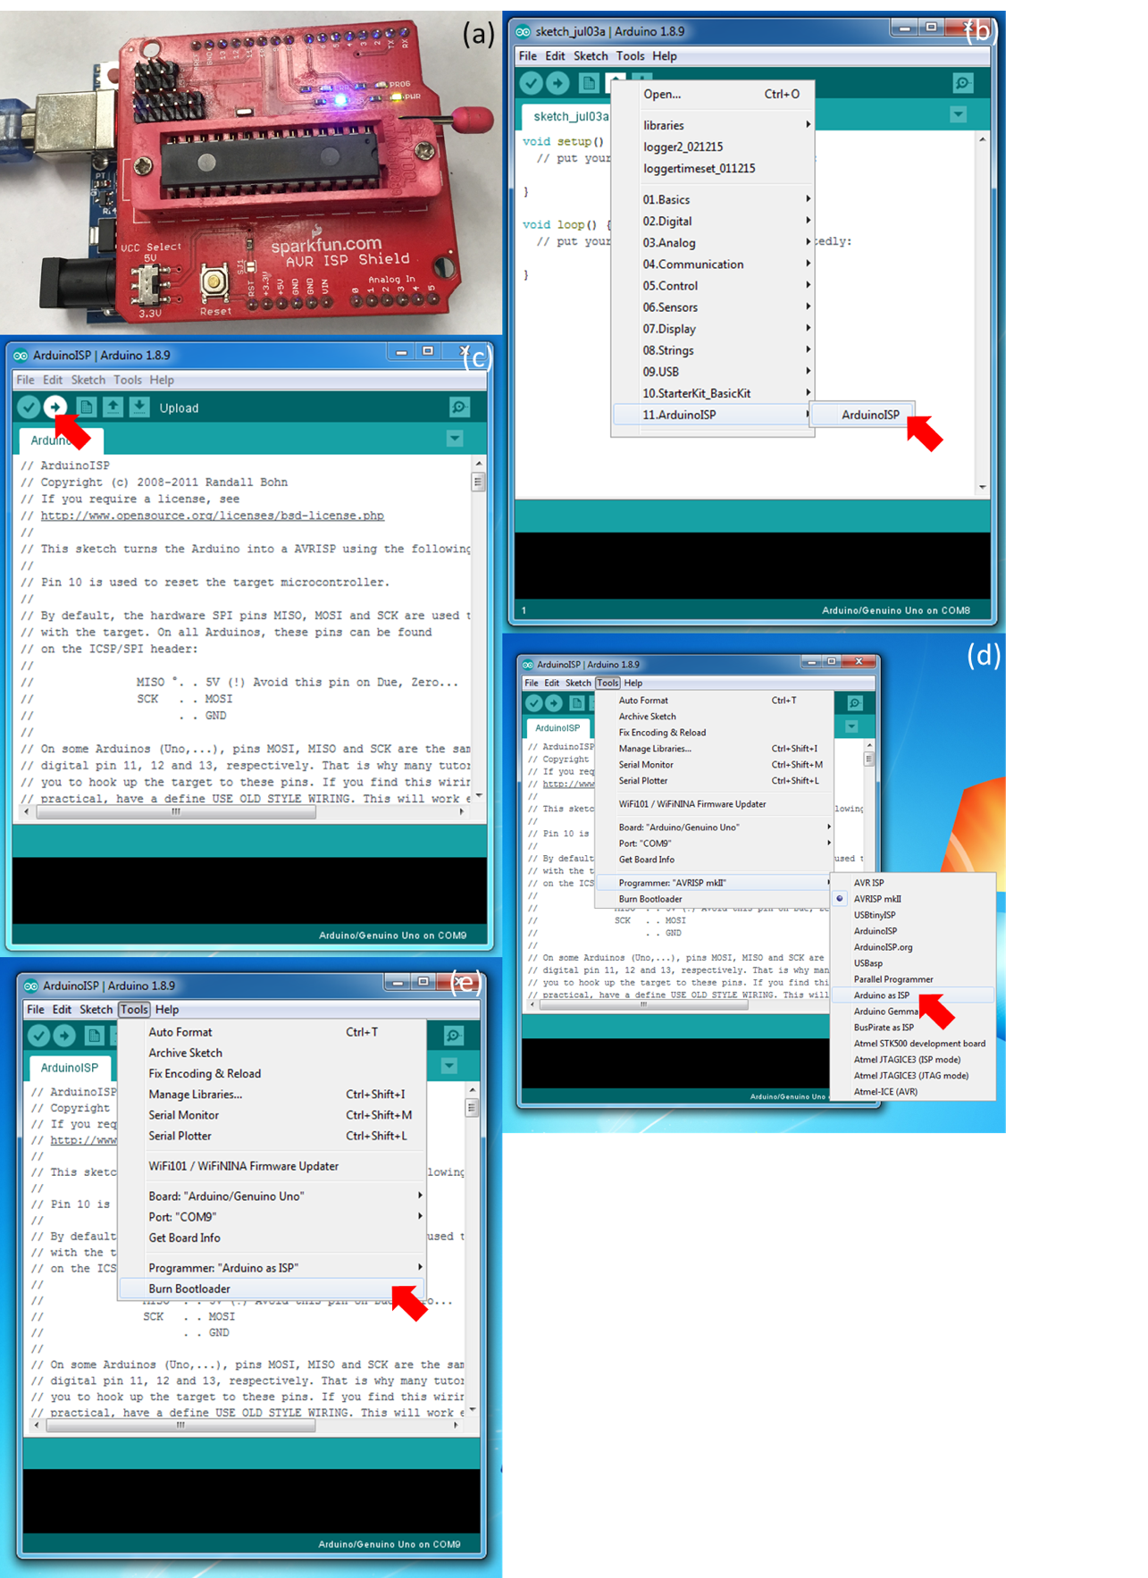

**Figure S14: (a)** AVR ISP programming shield with an ATMEGA328P chip inserted. Note the orientation of the notch on the chip. **(b)** Opening the Arduino ISP sketch. **(c)** Uploading the Arduino ISP sketch. **(d)** Setting the programming tool to Arduino as ISP. **(e)** Burning the bootloader.

*3.2 Programing the PIC12F683*

In order to carry out this next step, you will need to install and open the MPLABx IDE <https://www.microchip.com/mplab/mplab-x-ide> and the XC8 compiler <https://www.microchip.com/mplab/mplab-x-ide>. The MPLABx IDE is used to communicate between the computer, the PICKit3 and the PIC12F683. The XC8 compiler allows this communication to be written in the coding language C. The program which will be uploaded to the PIC12F683 has already been written and is located in the *‘temp_logger_files’* folder in the sub folder *‘MPLABXProjects’*. If this is the first time you are working with MPLABX, you will need to copy the files in this folder into the appropriate MPLABX directory on your computer. It should be titled ‘MPLABXProjects’. You will only have to transfer these files once.

In this step, we will be installing C code onto the PIC12F683. This code allows the data logger to power down between measurements and improve battery life. Start by connecting the PICkit3 to your computer and opening the MPLABx IDE. Now open the *temp_logger.X* project file by going to the file drop-down menu and selecting *File/Open Project* in the MPLABx IDE. If you transferred the files correctly, you should see the *temp_logger.X* project.

Next, setup the PICkit3 as a programmer by selecting the menu icon with a green down arrow and selecting *Upload/Programmer To Go PICkit3 Main Project* (figure S15a). Now you can upload the code to the PIC12F683 by inserting it into the zero-insertion force socket as shown (figure S15b) and pressing the black button on the PICkit3. Note that once the PICkit3 is set up as a ‘programmer to-go’ the steps involving the MPLABx IDE do not need to be repeated. As long as the programmer is powered via a USB port, pressing the black button will upload code to a chip.

The code is currently set to log data at a 20-minute interval. To alter this interval, open the code by going to Source Files/PIC12.c in the MPLABx IDE. Then change the value of the unsigned integer “interval” on line 51 of the code. You can calculate the desired value as follows: ***value = logging interval * (2008/21).***

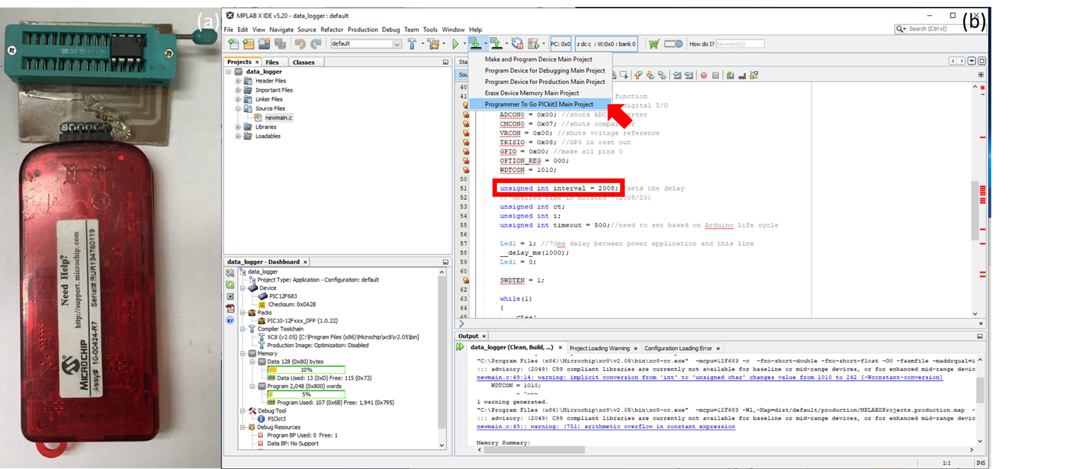

**Figure S15:** **(a)** PIC12F683 in the zero-insertion force socket for the PICkit3. Note that this is a custom-made socket so yours will look different. This step can also be performed using a bread board as mentioned above **(b)** Setting up the PiCkit3 as a programmer to go. Line 51 which controls the interval at which data is collected is highlighted.

*3.3 Inserting all four of the chips and prep for launch*

Now that the PIC12F683 and the ATMEGA328P chips are programmed, insert them and the additional two other chips (four total) into the circuit board as shown figure S16. The other two 2 chips (8-pin DS1307N and 14-pin SN74AHC125N) do not need additional programming. The 14- and 28-pin chips should be inserted into their applicable sockets. The two four pin chips look extremely similar so you will need to read the information printed on the component/package to tell them apart. The PIC12F683 socket is located in the upper right-hand corner in figure S16 and the socket for the DS1307 is located in the upper-left socket. Note that the chip should be oriented so the notch on the chip aligns with the notch in the socket. If the chips are inserted incorrectly, the temperature logger with malfunction Moreover, care should be taken when inserting the chips to ensure none of the pins become bent.

Lastly, insert the coin cell battery into the coin cell slot and insert a SD card into the SD slot. Double check to make sure that your SD card has available space and is not in the locked position. In the next steps, we will be run a program on the temperature logger that will test the ability of writing to the SD card. The program will also test the on-board clock which is powered by the coin cell battery.

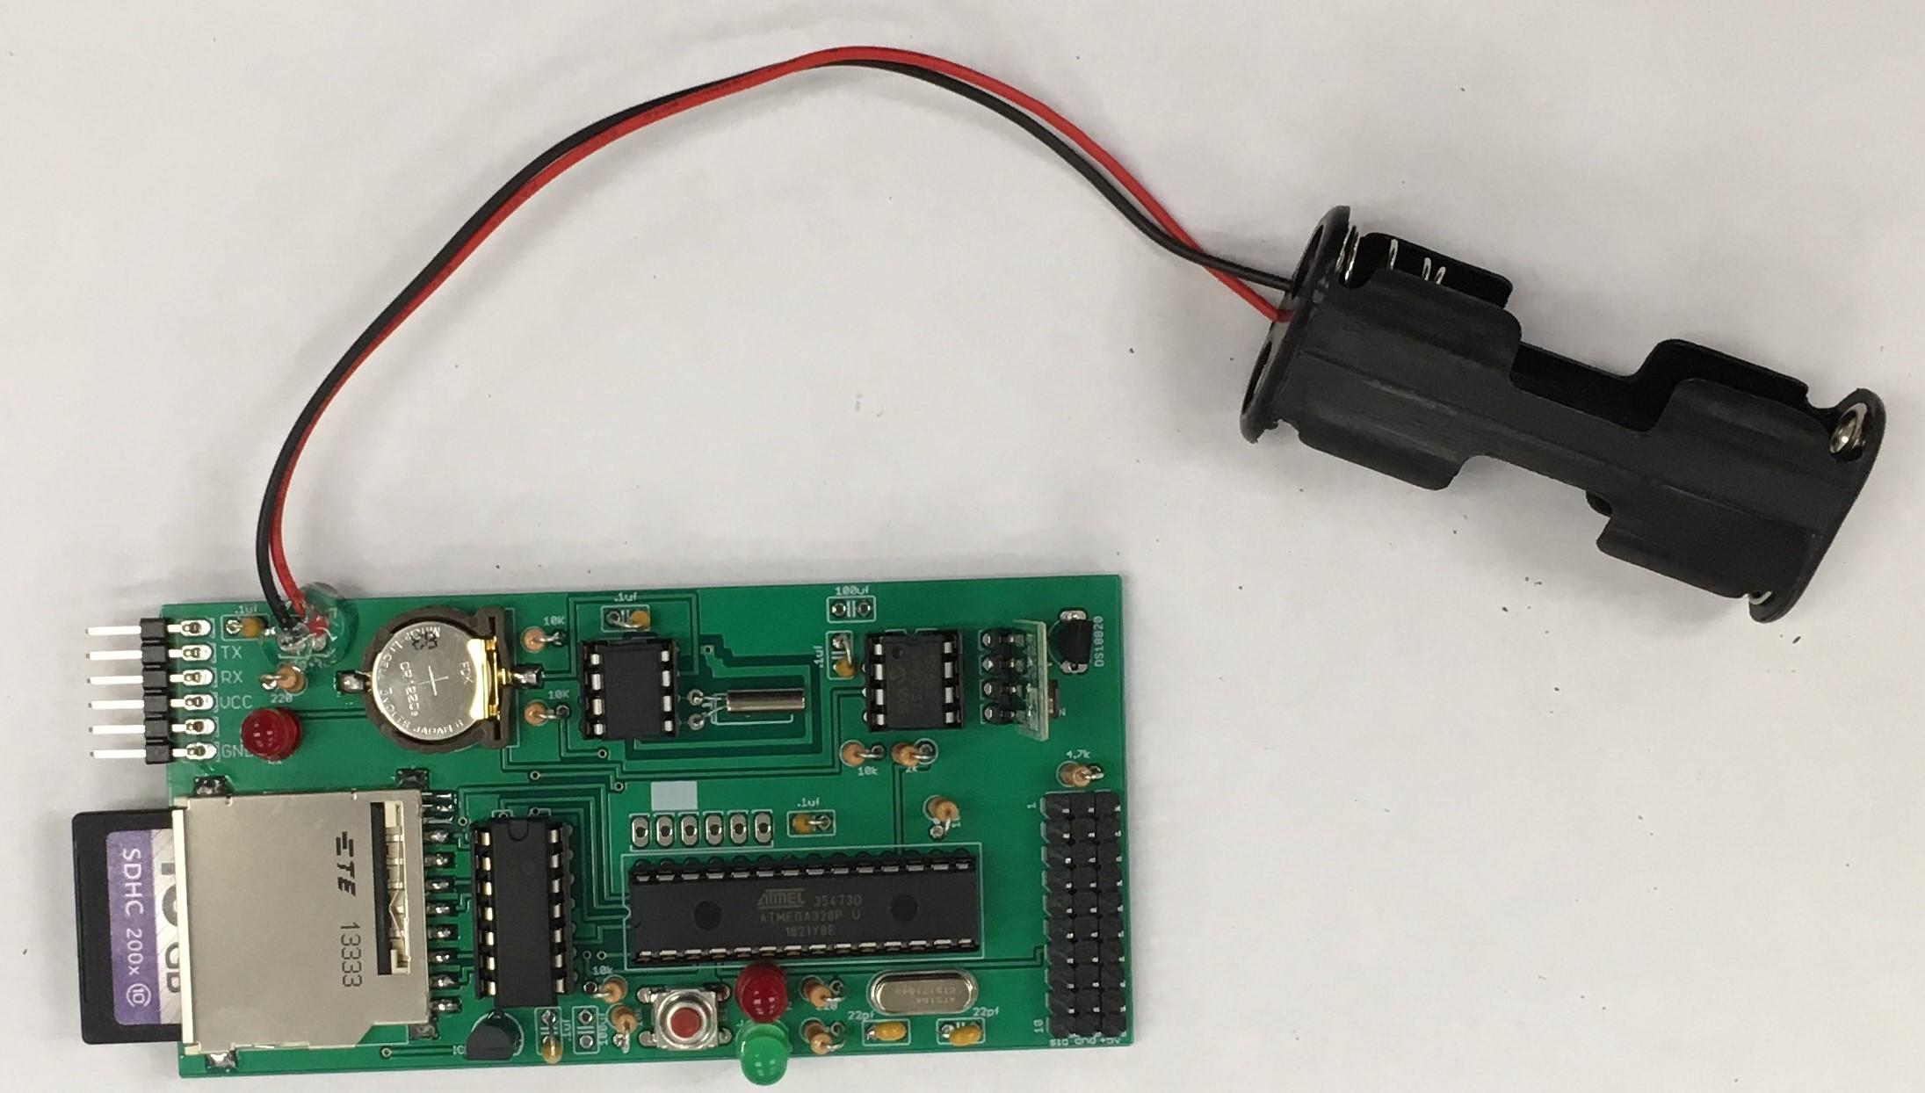

**Figure S16:** Printed circuit board with the chips properly inserted.

*3.4 Setting the data logger clock and temperature sensors*

In this step, we are going to upload two separate programs to the circuit board. The first is to set the clock and the second is to install the temperature probes assembled earlier and test them out.

Connect the temperature logger to your computer using the FTDI friend (figure S17a. The FTDI friend may require some set up (see: <https://learn.adafruit.com/ftdi-friend>). For the next steps, open up the Arduino IDE and change the programmer setting to ‘*AVRISP mkII’* by going in to the Tools drop-down menu and selecting *tools/programmer/AVRISP mkII* (figure S17b). Then open the ‘*set_clock.ino’* file located in the *‘arduino_files’* folder and upload the code to the circuit (figure S17c). You will need to download a number of libraries listed in the header of the file in order to compile the code (see: <https://www.arduino.cc/en/guide/libraries#toc3>). Alternatively, you can copy the files located in the ‘*arduino_files’* folder titled ‘*libraries’* and transfer them into the folder on your computer dedicated to Arduino libraries. It is important to have these libraries in the right place, otherwise the code will be unable to run appropriately. You can check which libraries you have installed by going to the Tools drop-down menu and selecting *Tools/Manage Libraries* and selecting ‘Installed’ from the *Type* drop-down menu. Next, open the ‘*log_temp.ino’* file located in the *‘arduino_files’* folder and upload this code to the circuit board via the FTDI friend. The small green and red LEDs on the FTDI friend will flash when code is being uploaded to the temperature logger. When the code is successfully uploaded, the Arduino IDE will give you a short message on the bottom of the window.

The ‘*log_temp.ino’* file contains the code which determines how many probes the logger will accept and therefore the number of temperatures it will record. You can make a small adjustment to this code to switch between a 2- and 10-probe logger as shown in this next image.

Simply comment-in line 63 or 64 of the sketch depending on which version of the logger you intend to build. You can comment-in a line of code by removing the first two “//” at the start of the line and you can comment out a line of code by adding “//” to the beginning of the line. If you wish to have a logger with an in between number of sensors, comment-in line 63 and comment out line 64 to make a 10-probe logger. In later steps, you can choose to add less than 10.

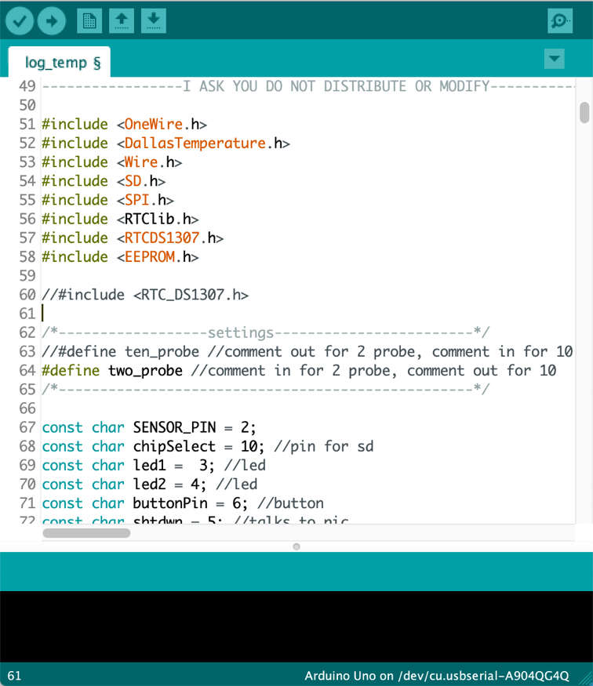

Once the code is uploaded, hold the red button on the circuit board and open the serial port in the Arduino IDE (figure S17d). Hold the button down until the LED’s turn on and text appears in the serial port. Note, the serial port baud rate must be set to 9600 baud for this to work (figure S17d). Follow the prompt on the serial port and the terminal will print some diagnostic information which you should look over. Then, follow the on-screen instructions to insert the temperature sensors. Make sure the sensor plug is properly oriented with the red/power cable of the probe attached to the pin labeled ‘+5v’ on the board. The sensors should be inserted one at a time into ports one to 10, pressing the red button between each new sensor which you plug in. The ports are ordered from the edge of the board inwards with the first port closest to the edge as shown in figure S17e. Once you’ve inserted the appropriate number of sensors, more information will print in the terminal window and you can then unplug the data logger from the computer.

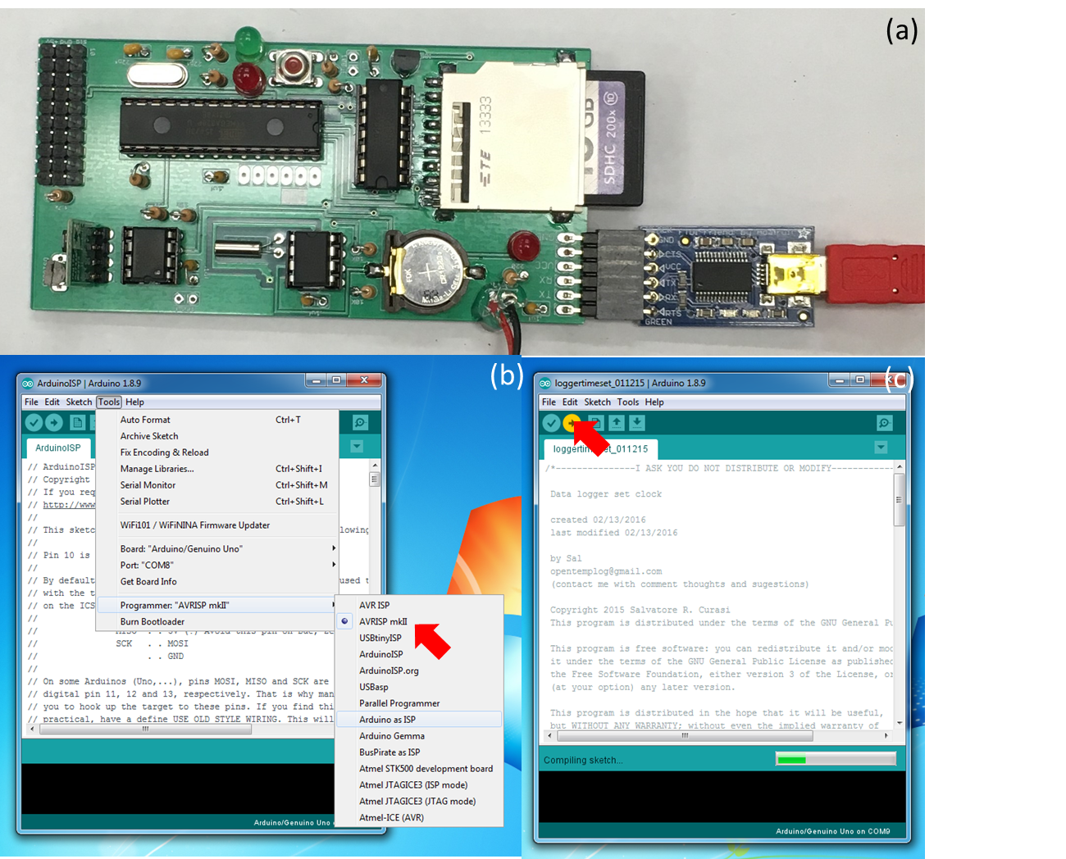

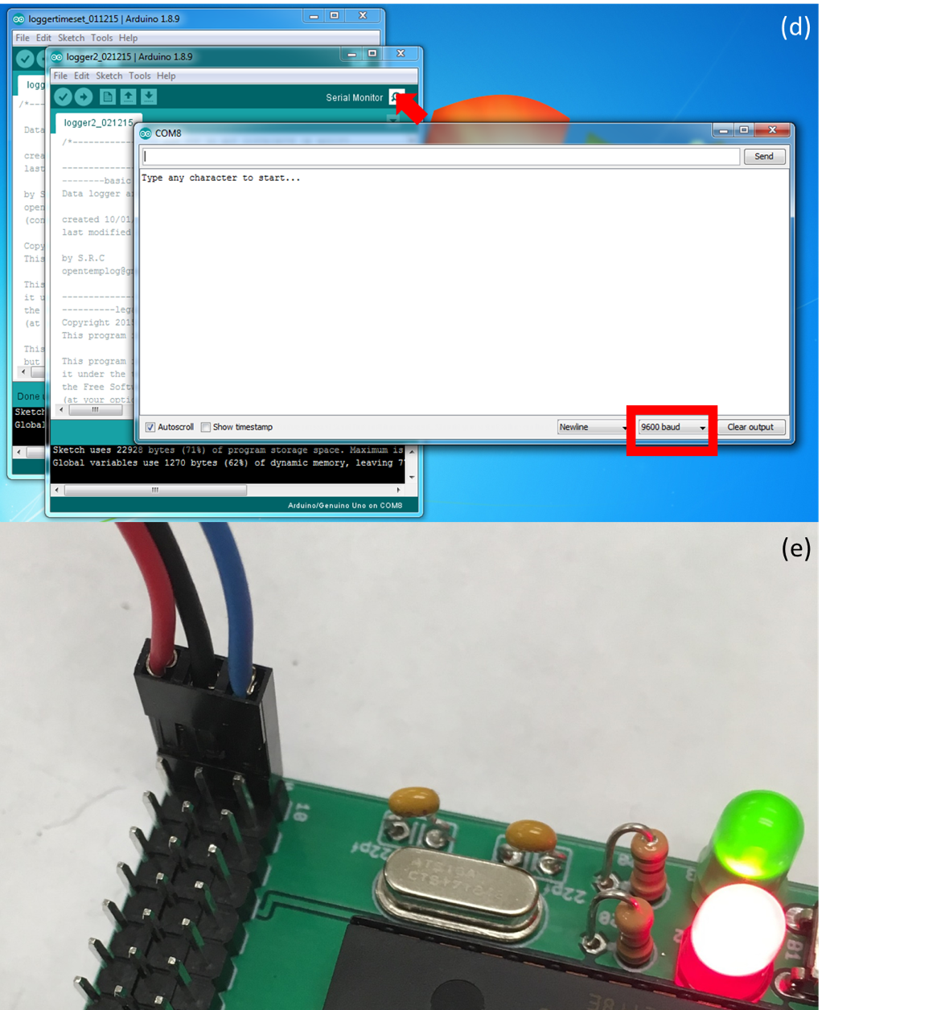

**Figure S17: (a)** Circuit board connected to computer using FTDI friend. **(b)** Setting the correct programmer in the Arduino IDE. **(c)** Uploading the logger time set sketch. **(d)** Opening the serial port in the Arduino IDE. The drop-down menu used to set the baud rate is highlighted. **(e)** A temperature sensor properly inserted into the circuit board.

*3.5 Note on interpreting the terminal window*

The terminal window that opens from the Arduino IDE offers information that can help debug the temperature logger if it isn’t working. Firstly, if the 3rd line of text does not read as ‘Writing to test.txt...done’, then this means that your SD card is either not plugged in completely, is in the locked position, or is otherwise damaged. You can try swapping out to a new SD card or double checking the solder connections between the board and the SD card slot.

After you have added the temperature probes, the window will report the temperatures recorded by each of the probes which will be listed as a ‘Device’. ‘Device 0’ is the internal DS18B20 sensor that you installed directly onto the board. The remaining ‘Devices’ increase as the probes move inward on the board away from the edge. ‘Device 1’ will be the probe connected closet to the edge of the board whereas ‘Device 10’ will be the probe inserted into pins on the opposite end. The temperature reported by the devices is in Celsius. The probes take a short while to adjust to ambient temperature. So, don’t be concerned if multiple probes don’t read the same temperature right away, or if one probe reports a high temperature after you were holding it.

If a probe/device ever reports the temperature -127.00C, this means that the probe is either not inserted correctly or is malfunctioning. To remedy this, first try and repeat the process outlined in step 3.4. If this does not solve the issue, check the cable connection at the end of the temperature probe to make sure that the crimp contacts are inserted completely into the housing and that there is no damage to the external wire housing. You can also try and replicate the error in a separate position, in which case the probe makes be defective.

*3.6 Completion*

Now you’ve completed the set up and construction of the temperature logger! In order to start recording temperature, insert two AA batteries into the battery holder. The red LED on the front of the board should flash on indicating that the device is now active. In order to retrieve the data, pull out the SD card and copy the *‘LOG.csv’* file located there onto your computer. If the temperature logger is going to be used outside in winter/low temperatures, you should use lithium batteries as alkaline batteries may not provide enough current to run the logger when exposed to cold temperatures.

**Methods S4:** Weatherproof enclosures

A waterproof enclosure is essential for the proper functioning of the temperature logger in remote environments exposed to weather. In our experience, most of our temperature loggers failed due to exposure to water.

A basic weatherproof enclosure for the temperature logger can be constructed as follows from the commonly available materials (see table S4, figure S18a and *all_tools_and_parts_list.xlsx* for details). Feel free to use other enclosure designs. However, the 4-port cable gland, 1/2-inch NPT pipe tap, and 45/64 drill bit are the appropriate size for creating a water-tight port in which 4 temperature probes will fit.

|  |  |  |
| --- | --- | --- |
| **ID** | **Description** | **URL** |
| 1 | Flexible Cap |  |
| 2 | 4-inch schedule 40 PVC pipe |  |
| 3 | Flat PVC cap |  |
| 4 | 4-port cable gland | [www.mcmaster.com/7807k39](http://www.mcmaster.com/7807k39) |
|  | PVC primer and solvent cement |  |
|  | ½”-14 NPT Pipe Tap |  |
|  | 45/64 in drill bit |  |

**Table S4:** Parts list for a simple weatherproof enclosure. The ID column references the annotations on figure S18a.

Glue a flat end cap to the end of a 6-8 inch long section of 4 inch schedule 40 PVC pipe using primer and solvent cement. A hole can be drilled in the center of the flat end of the cap using the 45/64 drill bit. The hole can then be threaded using a ½ inch NPT pipe tape. A cable gland can then be screwed into the tapped hole (note: wrapping the cable gland threads in plumbers’ tape will improve the water tightness. This is recommended for data loggers with <=4 channels). The data logger should be placed into the enclosure and the sensor wires threaded through the cable gland or smaller pipe segment (figure S18b). A flexible end cap can then be used to seal the open end of the enclosure and allow easy access to the SD card slot.

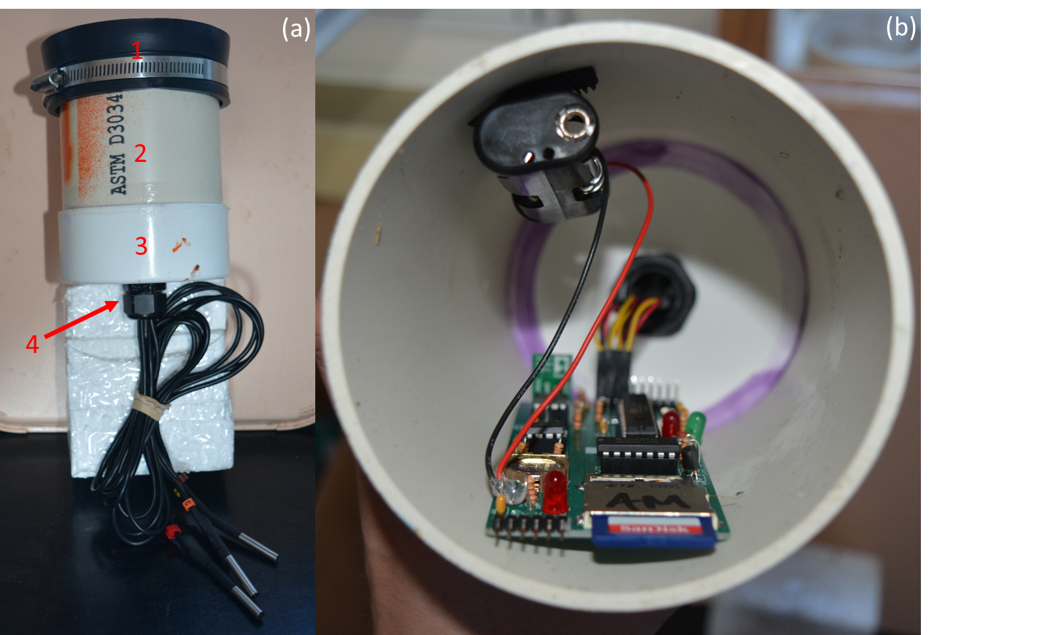**Figure S18: (a)** Weather-proof enclosure utilized a cable gland. **(b)** Temperature data logger installed in the enclosure.

The DS18B20 sensor probes have been test in saturated soil environments. However, if they will be immersed in water, we suggest adding an additional layer of waterproof heat shrink between the wire and sensor.